

CS-204 | Software Requirement Engineering

Project

BSSE 3rd Semester

SRS Document on Inventory Management System

**Submitted to:**

**Dr. Saima Shaheen**

**Submitted by:**

Jibran Bilal Khan (20-SE-040)

Aliha Shehzad (20-SE-060)

Muhammad Usman (20-SE-033)

Arslan Dilshad (20-SE-046)

HITEC University, Taxila

**Table of Content**

1. **Introduction**
   1. **Purpose**
   2. **Scope**
   3. **Definition, Acronyms, Abbreviations**
   4. **References**
   5. **Overview**
2. **General Description**
   1. **Software Perspective**
   2. **Software functions**
3. **Administrator**
4. **Customer**
   1. **Assumptions and Dependencies**
5. **Specific Requirements**
   1. **External Interface Requirements**
      1. **User Interfaces**
      2. **Hardware Interfaces**
      3. **Software Interfaces**
      4. **Communication Interfaces**

**Use-Case Diagram**

**Activity Diagram**

**User Interface**

**Layout 1**

**Layout 2**

**Layout 3**

**Layout 4**

**Layout 5**

**Layout 6**

**Layout 7**

**Layout 8**

**Layout 9**

**ER Diagram**

* 1. **Functional Requirements**
     1. **Customer Registration**
     2. **Product Management**
     3. **Authentication**
     4. **Validation**
     5. **Browse Stock Details**
     6. **Update Stock**
     7. **Enter New Item in Inventory**
     8. **Remove Item**
     9. **Place an Order**
     10. **Generate Invoice**
  2. **Non-Functional Requirements**
     1. **Performance**

1. **Static Requirements**
2. **Number of Terminals**
3. **Number of Users**
4. **Dynamic Requirements**
   * 1. **Usability**
     2. **Security**
     3. **Privacy**
     4. **User-Friendly**
     5. **Extensibility**
     6. **Reliability**
     7. **Availibility**
     8. **Security**
     9. **Maintainability**
     10. **Portability**
   1. **Design Constraints**
   2. **Database**
5. **Introduction**

Inventory management system has become important factor in modern business field. This system should help the businessmen to streamline the administrative task and provide real-time access to the data, Building this system in standalone application interface will further help the ease of accessibility through the provided portal. The study findings enable the definition of the project problem statement, its objectives, scopes and advantages of the inventory management system.

* 1. **Purpose**

The purpose of this document is to present a detailed description of the inventory management system, it will explain the purpose and features of the software, the interfaces of the software, what the software will do, the constraints under which it must operate and how the software will react to external stimuli, this document is intended for both the end users and the developers of the software.

* 1. **Scope**

This document covers the requirements for the inventory management system. This software will provide a graphical environment in which the users of the system will be able to perform various operations that are associated with storing, marinating, updating and retrieving product information. The purpose of this is to guide developers in selecting a design that will be able to accommodate the full-scale application. This system will capture information about customer’s personal details products and their quantities. Storing, updating and retrieving in a fast and secure way.

* 1. **Definitions, Acronyms and Abbreviations**

The inventory management system has to handle records for the number of products and maintenance was difficult. Though it has used an informing system, it was totally manual. Hence there is a need to upgrade the system with a computer-based information system.

* 1. **References**

An integrated approach to Software Engineering Approach – Pankaj Jalote

Software Engineering A practitioner’s Approach - Roger S Pressman

* 1. **Overview**

The purpose of this document is to present a detailed description of the inventory management system, it will explain the purpose and features of the software, the interface of the software will react to external stimuli. This document is intended for both the end users and the developers of the software.

1. **General Description**
   1. **Software Perspective**

The product inventory management system, is an independent product and does not depend on any other product or system. The product will automate various tasks associated with handling product details and better organizing the stored information and optimum performance, thus helping the businesses to ensure smooth working of these processes.

* 1. **Software Functions**

Our system has two types of access modes;

1. Administrator
2. Customer

**I**. **Administrator**

IMS is managed by Administrator, admin has to update and monitor the registered product details, add a new product, provide product numbers for all projects, assign each product details, add a new product, provide product number for all products, assign each product quantity and GST etc., Administrator can be update his profile and also can give help to the customers.

**II. Customer**

Customer can purchase the products and make payment accordingly. All this data will be saved into the database by the administrator to keep record of the sold products.

**2.3 Assumptions and Dependencies**

* We assume that the office personnel do all the data entry based and the correct values obtained from forms and registers.
* We assume that the computers that will use the software will be part of the having proper platform to run it.
* Users with administrator access should be careful in deleting or modifying any information knowingly or unknowingly which will lead to inconsistency of the database.
* The end users of this software are assumed to have basic level of computer knowledge i.e point and click.

1. **Specific Requirements**
   1. **External Interface Requirements**
      1. **user interfaces**

* GUI along with meaningful frames and buttons
* Reports are generated as per the requirement
  + 1. **Hardware Interfaces**

Hardware Environment : Dual Core 2nd Gen or Above

System Configuration : Ram-4GB HDD-80GB

Operation System : Windows 7 (64-bit) or above

* + 1. **Software interfaces**

Front end: JAVA

Back end: C++

When invalid inputs are given to the modules then the error messages will be popped up in order to inform the user that the input provided is not taken by the database. When incomplete information is provided by the user and the user tries to submit the form in order to store the details in the database. The system will pop up a message box asking the user to enter all the details required.

* + 1. **Communication Interfaces**

The machine will have to be part of the college local area network to access the central database

**Deliverables**

These are the following deliverables for the project on inventory control system.

1. **Software Project Management Plan (SPMP)**

It describes the outline of the entire project including details like people working in the project the guidelines needed to be followed in the project and also the entire duration of the project. Project on Inventory Control System (PICS) Software Requirement Specification (Version 1.4) 8 Date: 27/09/2013

1. **Software Requirements Specifications (SRS)**

It describes the requirements put forward by the client. The requirements includes functional and non-functional as well.

1. **Software Architecture Design Document (SADD)**

It describes the overall design of the system.

1. **Work Breakdown Structure**

It describes the breakdown of work by each team member involved in the project and also defines the total scope of the project.

1. **Milestone Report**

It describes the present status and important milestones of the project.

1. **Software Design Document (SDD)**

It is the in detailed design of the system which involves series of the diagrams like, class diagrams, use case diagrams, sequence diagrams and collaboration diagrams.

1. **Risk Management Plan**

It describes the methods to manage risks involved in the project.

1. **Quality Assurance Plan**

It involves methods and processes to make sure the end product in the project meets the required the quality level.

1. **Source and Object Code**

This is the part of deliverables which allows the client to run the code and maintain the required project. Project on Inventory Control System (PICS) Software Requirement Specification (Version 1.4) 9 Date: 27/09/2013

1. **User Manual**

It displays the system functionality and guide lines for the user to operate the project.

|  |  |  |
| --- | --- | --- |
| **Task** | **Due Date** | **Responsible Member** |
| Software Project Management Plan (SPMP) | 10/01/2013 | ALL |
| Software Requirements Specifications (SRS) | 17/01/2022 | ALL |
| Software Architecture Design Document (SADD) | 9/01/2022 | ALL |
| Work Breakdown Structure | 14/01/2022 | ALL |
| Milestone Report | 27/01/2022 | ALL |
| Software Design Document (SDD) | 30/01/2022 | ALL |
| Risk Management Plan | 03/02/2022 | ALL |
| Quality Assurance Plan | 03/02/2022 | ALL |
| Source and Object Code | 03/02/2022 | ALL |
| User Manual | 14/02/2022 | ALL |

**Length of the Project**

In this project each team member is required to spend 200 hours duration for the project. In our PICS team, there are four members which equate to spending a total 800 hours over the length of the project.

|  |  |  |
| --- | --- | --- |
| Work Package/ Action Performed | Responsible Member | Time Duration |
| Software Project Management Plan (SPMP) | ALL | 75 Hours |
| Software Requirements Specifications (SRS) | ALL | 75 Hours |
| Software Architecture Design Document (SADD) / Software Design Document (SDD) | ALL | 150 Hours |
| Work Breakdown Structure | ALL | 70 Hours |
| Milestone Report | ALL | 80 Hours |
| Risk Management Plan | ALL | 100 Hours |
| Quality Assurance Plan | ALL | 100 Hours |
| Source and Object Code / User Manual | ALL | 150 Hours |
| Total | ALL | 800 Hours |

**USE CASE DIAGRAM:**

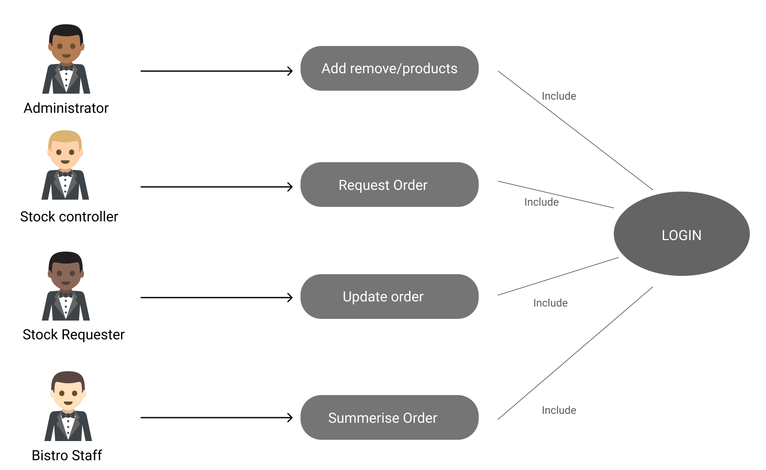

**Activity diagram:**

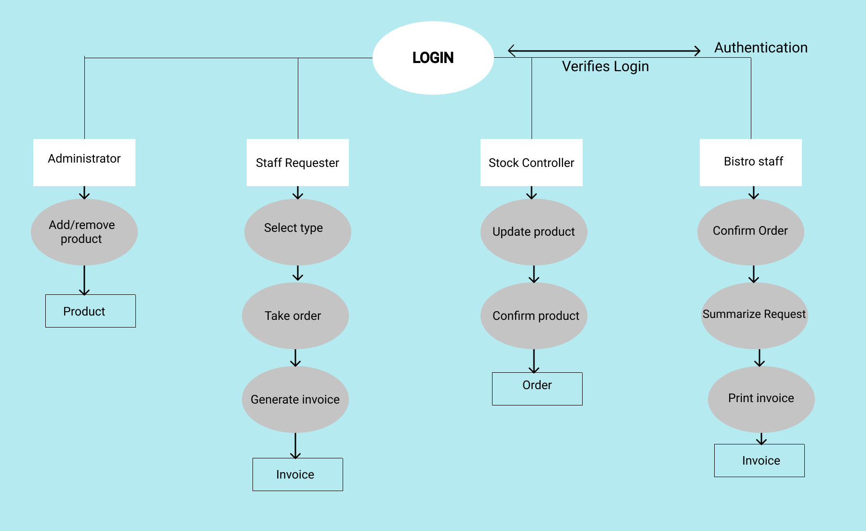

**User interface:**

**Layout 1:**

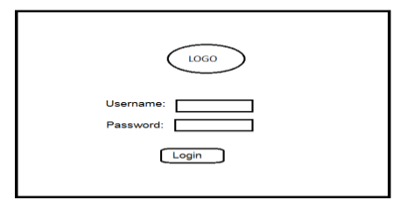

**Layout 2:**

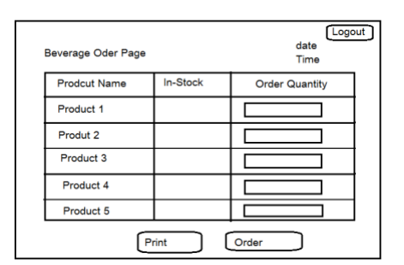

**Layout 3:**

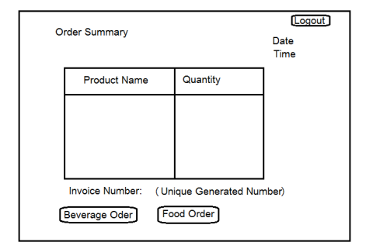

**Layout 4:**

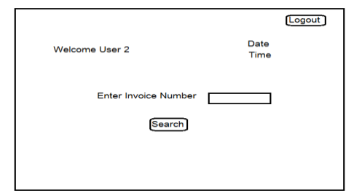

**Layout 5:**

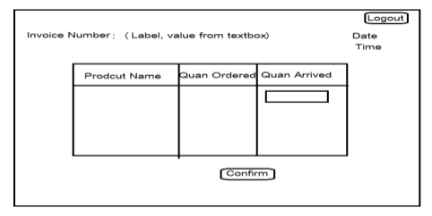

**Layout 6:**

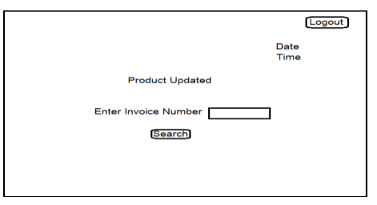

**Layout 7:**

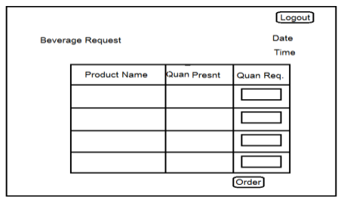

**Layout 8:**

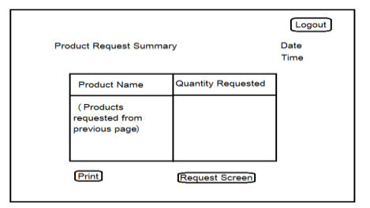

**Layout 9:**

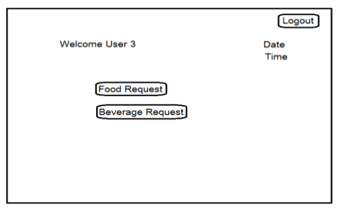

**ER Diagram**

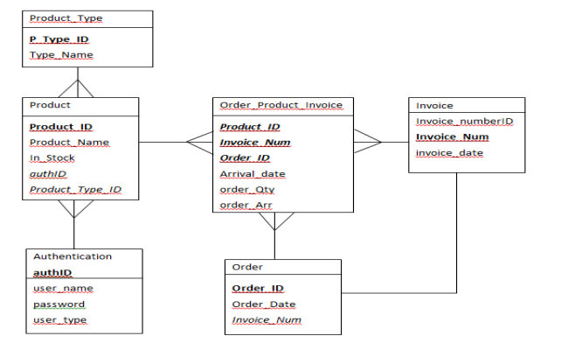

* 1. **Functional Requirements**

Inventory management system involves the following functions

* + 1. **Customer Registration:**
* IMS provides customer registration and status information to the administrator to view their status
* IMS provides automatic customer register number generation based on randomization algorithm
* IMS provides to customer to purchase products and enlist them in their profiles
  + 1. **Product Management**
* Easily track product information (sold and available)
* Quickly produce reports for single or multiple sold products.
  + 1. **Authentication**

The new system will provide the functionality that allows the client and manager of rundle bistro bar to login to the new system with their unique username and password. Then they will be guided to the next page based on their username. **(Essential)**

* + 1. **Validation**

If the client will enter the wrong username or password, then they cannot access or login to the new system. **(Essential)**

* + 1. **Browse stock details**

The new system will allows the client to browse all the available stock details after successful login in to the system. **(Essential)**

* + 1. **Update stock**

This function allows manager and stake holder update the details of the stock. **(Essential)**

* + 1. **Enter new item in inventory**

This function allows user to enter or add the new item in the inventory. **(Essential)**

* + 1. **Remove item**

This function allows user to remove or delete the item from the stock. **(Essential)**

* + 1. **Place an order**

This function allows user to place an order for the required stock to the respective supplier. **(Essential)**

* + 1. **Generate invoice**

The new system will also have the functionality to generate the invoice to check the ordered stock. **(Essential)**

* 1. **Non-Functional Requirements**

**3.3.1 Performance**

Easy tracking of record and updating can be done. All the requirements relating to performance characteristics of the system are specified in the section below. There are two types of requirements

1. **Static requirements**

These requirements do not impose any constraints on the execution characteristics of the system. They are:

1. **Number of terminals:**

The software makes user of an underlying database that will reside at the same system, while the front end will be available to the administrative computer.

1. **Number of users:**

The number of users can be administrator only but this software can be extended to applications for almost all staff members of the organization

1. **Dynamic Requirements**

These specify constraints on the execution characteristics of the system. They typically include response time and throughout of the system. Since these factors are not applicable to the proposed software, it will suffice if the response time is high and the transactions are carried out precisely and quickly.

**3.3.2 Usability**

The new system will be simple and easy for the use to client. **(Essential)**

**3.3.3 Security**

The new system will be secure from the unauthorized access. **(Essential)**

**3.3.4 Privacy**

The new system will also provide the safety to the user details and stock details. **(Essential)**

**3.3.5 User-Friendly**

The new system will provide more interaction to the user so that user can easily interact with the new system. **(Essential)**

**3.3.6 Extensibility**

The new system will have extensibility in future for the implementation of the new stock or items. **(Negotiable)**

**3.3.7 Reliability**

The software will not be able to connect to the database in the event of the server being down due to a hardware or software failure

**3.3.8 Availability**

The software will be available only to administrator of the organization and the product as well as customer details will be recorded by him. He can add customers, update, and delete them as well as add new products and manage them.

**3.3.9 Security**

The security requirements deal with the primary security. The software should be handled only by the administrator and authorized users. Only the administrator has right to create new accounts and generating inventory. Only authorized users can access the system with username and password of administrator.

**3.3.10 Maintainability**

Backups for database are available.

**3.3.11 Portability**

**The software is a web-based application and is built in JAVA and SQL so it is platform independent and is independent of operating system.**

* 1. **Design Constraints**

This software provides security. The login form prevents the system from being misused by unauthorized users. Only an authorized operator will be granted rights to modify as per requirements. This software is also reliable and fault tolerant. The system developed is designed to handle invalid inputs. Since reliability is a major are of concern the system has a backup to avoid data loss. The user should know the programming language very well that is used to develop the software.

* 1. **Database**

All data will be stored in relational database.